CA-25
2016 IE Strategy Memorandum

Updated on 5/17/16

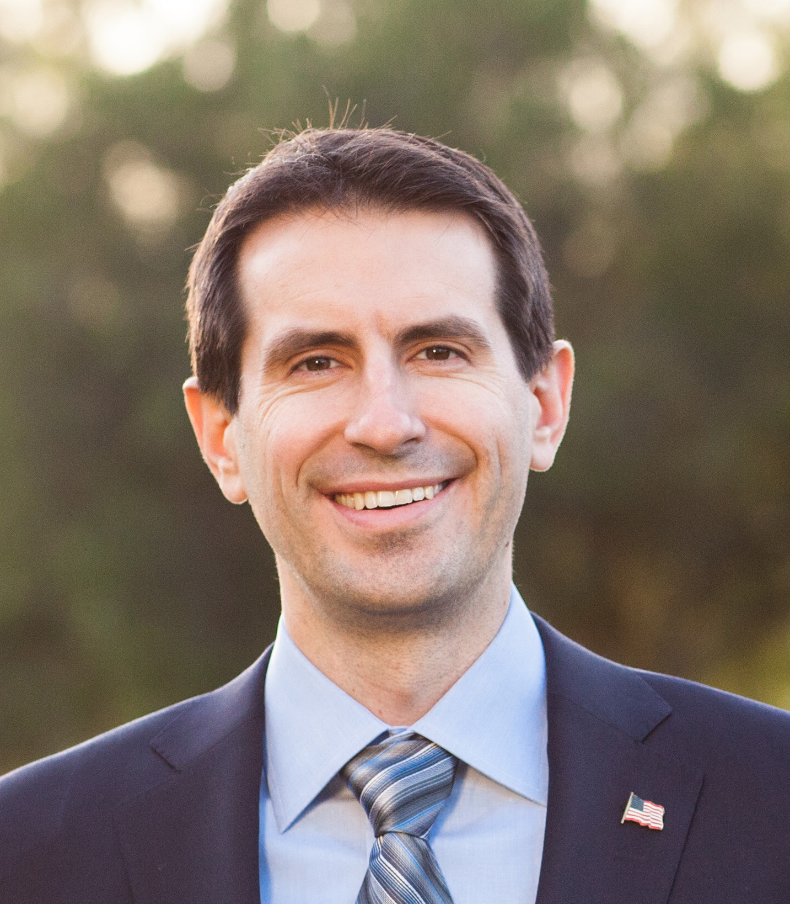
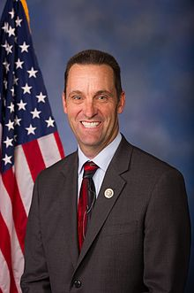

BRYAN CAFORIO STEVE KNIGHT
CoH: $205,492.72 CoH: $500,871.00
Date: 4/15/16 Date: 4/15/16
Occupation: Consumer Rights Attorney Occupation: Member of Congress

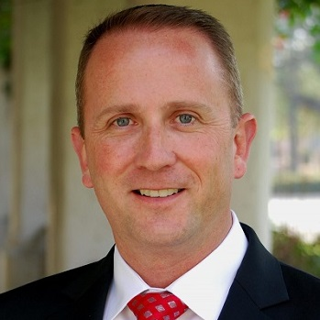
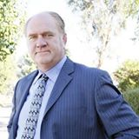

LOU VINCE JEFFEREY MOFFATT
CoH: $10,533.69 CoH:
Date: 4/15/16 Date 4/15/16
Occupation: Police Lieutenant/Councilmember Occupation: Federal Law Attorney

SECTION I: Race Overview
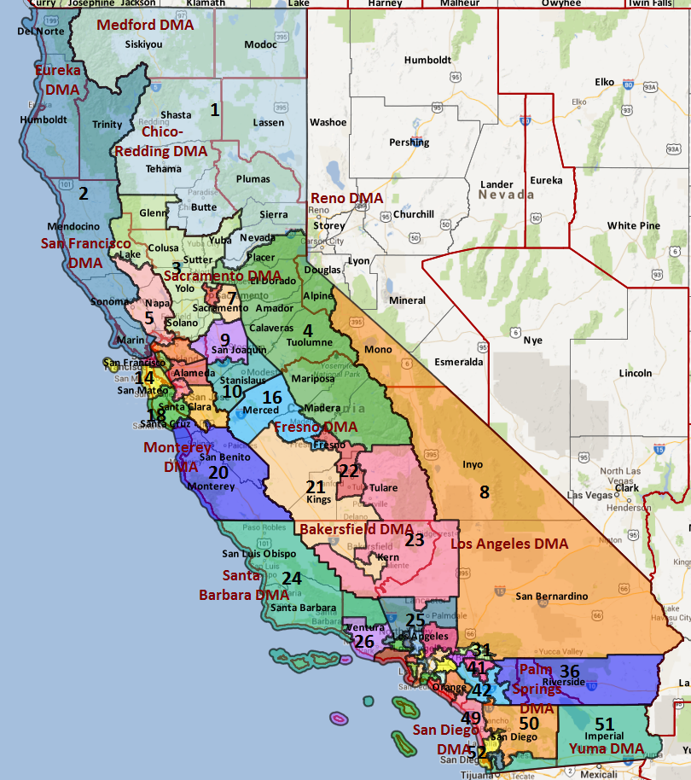

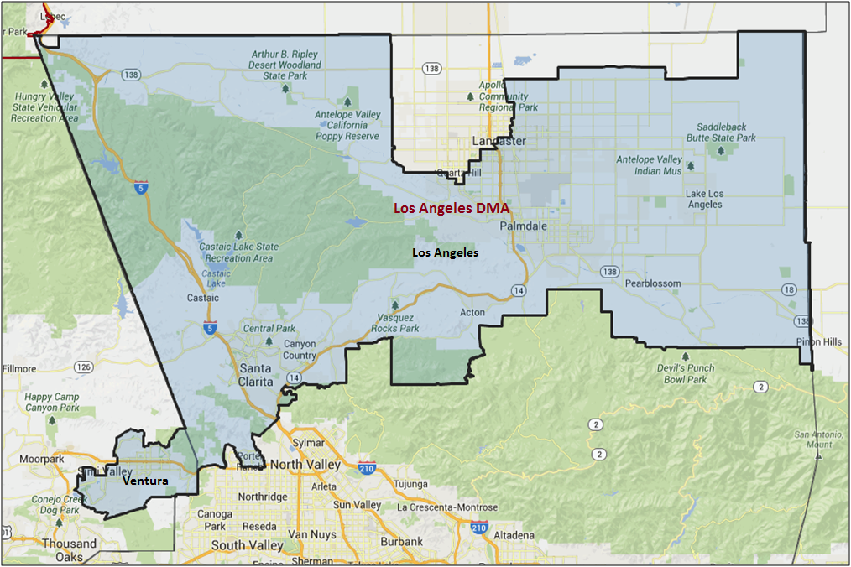

Media Market Costs

TV DMA | % of  CD | I.E.  35+ CPP | Cable CPP
LOS ANGELES | 100% | $1906 | $938
CA-25 TOTALS: | 100.0%
Radio Landscape

Los Angeles
Universe Size | CPP
5,690,900 | $1,350

Digital Landscape
  - Persuasion universe size: 28,203
  - Audience extension (key demos): Hispanic, 18-30
  - Weekly budget for full coverage: $10,323.86
  - Reach
    - YouTube - 320,579
    - Pandora - 271,209

Presidential Statistics
Cycle | Candidate | Party | Vote
2012 | Obama | DEM | 49.1%
2012 | Romney | REP | 50.9%
2008 | Obama | DEM | 50.6%
2008 | McCain | REP | 49.4%

Congressional Statistics
Cycle | W/L | Candidate | Party | Vote
2014 | L | STRICKLAND | REP | 46. 7%
2014 | W | KNIGHT | REP | 53.3%
2012 | L | ROGERS | DEM | 42.2%
2012 | W | MCKEON | REP | 57.8%

NCEC Data
Dem Performance: 46%
BVAP: 8.3%
Hispanic: 26.3%
Asian: 8.4%
Total Minority: 43%

Critical Dates
Filing Date: March 25th 2016
Primary Date: June 7th 2016

Summary of 2014 Cycle Spending by Outside Groups to Date
None

Summary of 2012 Spending by Outside Groups

None
Pre-Election Day Voting

Type of  “Early Voting” | Start Date  End Date | Percent of  Vote Cast Using this Method | Brief Description  (where/how  do people vote) | Timeframe (when does the majority of voting happen)
Early Vote | Oct 10 –Nov 8 |  | Voters can bring their early ballots to the board of elections office or be issued a ballot at the office at the time of their visit | Steadily between Oct 8 – Nov 7
Absentee Ballot/In person Absentee | Oct 10 – Nov 11 |  | Voters must apply for an absentee/VBM ballot via mail, online, or in person | Absentee applications must be received by BOE at least 7 days before election day
Vote By Mail | Oct 1 – Nov 11 |  | Voters must request to VBM each election unless on PEVL - VBM must be received by BOE by Nov 11 and be postmarked before election day | Ballots return steadily.

Tentative Campaign Timeline

IMPORTANT DATES

VBM: Oct. 10 – Nov. 1

EARLY/ ABSENTEE VOTING
- Counties begin sending out mail ballots on 10/10/2016.
- Per the PDI voter file, there are 148,012 permanent absentee voters in the district as of March 2016.
- According to Los Angeles and Ventra County election results, district voters cast 34.9% of ballots via mail in 2012 and 44.1% of ballots via mail in 2014.
- In 2014, 29% of mail ballots were returned by the end of week three and 64% were returned by the end of week two. A similar pattern occurred in the 2012 early vote period— 10% of ballots were returned by the end of week 4, 33% were retuned by the end of week 3, 70% of ballots were returned by the end of week two.
- Registered Republicans had a 15.7 lead over registered Democrats (47.7% to 32.1%, 20.2% DTS) for returned ballots in 2012 and a 14.2 point advantage over registered Democrats for ballots returned in 2014 (48.1% to 33.9%, 18.0% DTS.
- Lee Rogers won just 38.0% of mail ballots and 41.8% of poll ballots in 2012. In 2014, Knight won 44.5% of mail ballots and 57.2% of poll ballots to beat fellow Republican Tony Strickland.
- Due to the large share of ballots cast on Election Day, a successful candidate cannot rely on early vote support alone. Winning just 50% of poll votes would require a candidate to win 56% of vote-by-mail votes. Conversely, achieving a 50% support rate with vote-by-mail voters would necessitate a 53.0% support rate with poll voters. Therefore, the Caforio campaign must increase support with traditional Election Day and vote-by-mail voters.

SECTION II: DISTRICT OVERVIEW

- District Overview and Data

  - Political Landscape
- Two Democrats and two Republicans are running in the top-two CA-25 primary.
  - Republican incumbent Steve Knight, son of a beloved State Senator and Air Force test pilot, served in the State Assembly and Senate before running for Congress. A veteran and former police officer, Knight has been weakened by several scandals and lackluster fundraising.
  - Jeffery Moffatt, a tax attorney from Lancaster, changed his party registration to run as a Republican. The husband of a perennial State Senate candidate Star Moffatt, Moffatt finished seventh out of 11 candidates in the Palmdale School Board District election.
  - Bryan Caforio, a successful Santa Clarita attorney, outraised the field in his first quarter in the race, raising $138K in Q4 of 2015.
  - Los Angeles police office Lou Vince has won the California Democratic Party endorsement, but has failed to adequately fundraise and only had $20K cash on hand at the end of 2015.

  - District Demographics
- CA-25 is located in northern Los Angeles County (83.4% of the district) and eastern Ventra County (16.6% of the district), and includes the areas of Antelope Valley, Palmdale, Lancaster, Santa Clarita and Simi Valley. It is the only Los Angeles County congressional district currently represented by a Republican.
- The expensive Los Angeles media market ($1,906 political cost per point) covers the entire district, which has historically made an earned media strategy is extremely difficult.
- A majority suburban district, CA-25 has a large minority population (43% of Citizen Voting Age Population). Over a quarter (26.3%) of the Citizen Voting Age Population is Hispanic and 37.6% of the population speaks Spanish. The average household income is $70,727, 14 points higher than the state average and 31 points higher than the national average; however, only 26.3% of the district has completed a Bachelor’s degree, 5.5 points lower than the state average.
- California is a party registration state. Throughout this memo, references to partisanship reflect either registration as listed on the file, or modeled partisanship via Catalist’s National Partisanship Model.

District Demographics

- Cook Partisan Voting Index: Lean Rep
- Urban Population: 26.2%
- Rural Population: 21%
- Suburban Population: 52.9%
- Median Income: $70,727
- Poverty Status: 8.8%
- Military Veterans: 8%
- Race/Ethnic Origin: 57% White; 8.3% Black; 8.4% Asian; 26.3% Hispanic Origin

  - Electoral Context
- According to the Secretary of State, 252,249 ballots were cast in the 2012 general election, for a turnout rate of 71.5%. Therefore, we expect 71.5% of voters will cast ballots in the 2016 election (262,590 ballots cast, when applied to the district’s current registration).
- To win 52% of the vote, a successful Democratic candidate will need 136,546 votes, and a one-point shift in support equals 2,626 votes.
- Per official registration statistics, registration has significantly improved in Democrats’ favor. Democratic registration has increased 1.1 points and Republican registration has decreased 2.3 points since 2012. As a result, Democratic and Republican registration shares are now functionally tied (36.5% to 37.1% respectively). No party preference/decline to state registration has also increased 4 points since the 2012 general election.
- During the last presidential election, 6.2% of voters who voted at the presidential level did not vote at the congressional level. Democrats were hurt by a high Democratic roll off rate, as 11.4% of Obama voters neglected to vote for Rogers and 3.5% more people voted for McKeon than Romney.
- Per initial national generic support and turnout modeling, the Democratic base resides in pockets in and around Santa Clarita, Palmdale, Antelope Center and Val Verde. Persuasion targets, as defined by national models, are located throughout the district except for areas of Palmdale and Lancaster east of 14. Turnout targets reside in Humphries and Desert View Highlands, Antelope Center and near Palmdale, excluding the airport.
- The Senate race’s effect on the Congressional race will depend on the outcome of the jungle primary.
- It is now much easier for a ballot initiative to qualify for the ballot, and we therefore expect a very high number of ballot measures to appear in 2016. Ballot initiatives that may impact the electorate include:
- A possible initiative that will legalize the recreational use of marijuana
- A ban of the possession and sale of large ammunition clips Proposition 30 extensions that would continue higher income tax for the wealthiest Californians
- School Funding and Budget Stability Act that would extend Prop 30’s income tax increases through 2030 and fund K-14 education
- The “Invest in California’s Children Act,” which would impose higher rates on individual tax filers earning more than $1 million per year
- One major rule change will impact our races in 2016. Senate Bill 29 rules that boards of elections must count absentee ballots that arrive up to three days after the election that are postmarked on or before Election Day. Previously, only ballots received by Election Day were counted. The new DMV voter registration legislation, known widely as “New Motor Voter,” will not be in effect prior to the 2016 cycle

  - Press Presence
The Los Angeles Media market is incredibly crowded. However, Knight’s status as one of two remaining Republicans in LA County (McCarthy is the other), Knight’s “I’ll drop your ass” incident, and the Porter Ranch gas leak have helped drive some coverage of him and the district.

- Paper of Record: Los Angeles Times - Javier Panzar
- Large local papers: The Ventura County Star (Bart Sullivan), LA Daily News (leans conservative), and the Santa Clarita Valley Signal (they plan to hire a political reporter)
- Others: Antelope Valley Press and the Acorn group of papers

SECTION III: MESSAGE

Message Box

Democrat Self Frame  Bryan Caforio is a Democrat from Santa Clarita and a Southern California native. He learned the value of hard work and a great public education from his parents, both California public school teachers. Bryan's worked as an attorney where he’s taken on some of the biggest banks in America and won. He's seen firsthand a system that's rigged in favor of big banks and corporations and against the middle class. He'll work in Congress to help hardworking Americans get ahead by raising wages and strengthening benefits like paid leave. | Republican Self Frame  Integrity; It’s something that I’ve provided as both a police officer and elected leader for the last three decades. On my watch: job opportunities will stop being lost to neighboring regions and states, our children’s future will not be jeopardized by irresponsible spending, and our safety will always be priority number one.
Likeliest Attacks on Democrat  Caforio is a 33-year old millionaire who doesn’t understand what it’s like for regular people. He graduated from Yale Law School and then became a partner in a massive law firm, earning hundreds of thousands of dollars a year. We don’t need another millionaire in Congress who will look out for rich people like himself.  Caforio is a partner at a law firm that represents some of the largest oil and gas companies in America | Best Attacks on Republican  - Was caught on camera telling an immigration reform protester, “I’ll drop your ass”  - Enjoys the perks of public office—had to pay the government back $1,000 he was improperly reimbursed for hotels and transportation in DC; received $34,567 in gifts in the state house; attended conferences in Hawaii  - Voted against removing Confederate symbols from the House and against removing the Confederate Battle Flag from government-run gift shops  - Opposed to abortion without any exceptions

- Bryan Caforio (D)

- Short Biography
Bryan is a Southern California native. Bryan attended and graduated from UCLA, and then Yale Law School, where he helped represent tenants in need. After graduating from Yale, Bryan started his career by going into public service and working for a United States federal judge. For the last seven years, Bryan has practiced as an attorney in Southern California, where he has taken on some of the biggest banks in the world, and won.

- Self-Frame
Bryan Caforio is a Democrat from Santa Clarita and a Southern California native. He learned the value of hard work and a great public education from his parents, both California public school teachers. Bryan's worked as an attorney where he’s taken on some of the biggest banks in America and won. He's seen firsthand a system that's rigged in favor of big banks and corporations and against the middle class. He'll work in Congress to help hardworking Americans get ahead by raising wages and strengthening benefits like paid leave.

- Likely Attacks
- Caforio moved to the district from the Beverly Hills area where he still owns a home, and he’s only temporarily renting here while he runs for office. He is just trying to go to Congress. He doesn’t really care about the people here. He just cares about himself.
- Caforio is a 33-year old millionaire who doesn’t understand what it’s like for regular people. He graduated from Yale Law School and then became a partner in a massive law firm, earning hundreds of thousands of dollars a year. We don’t need another millionaire in Congress who will look out for rich people like himself.
- Caforio is a partner at a law firm that represents some of the largest oil and gas companies in America--even companies who have spilled dangerous chemicals to poison ground water, those who conduct fracking and oil companies trying to build the Keystone Pipeline. We need a Congressman who will get tough on the Porter Ranch gas company Sempra Energy, not one who shields them from Wrongdoing.
- As a Beverly Hills lawyer, Caforio has represented Wall Street banks and powerful CEOs. He even represented Wall Street banks who were creating investments called life settlements that bet on people dying to collect life insurance. Caforio's hedge funds got rich when seniors and AIDS patients died early.

- Assessment of Democratic Fundraising

Bryan Caforio | Q4 2015 | Q1 2016
Goal | $100,000 | $325,000
Actual Raised | $138,835 | $163,842

- Strengths and Weaknesses of Campaign

- Market:
  - The district is located in the expensive Los Angeles media market.
  - The district is situated outside the Los Angeles City limits, and far from the major press outlets in the market.
- Infrastructure:
  - Caforio is new to the district and has no built up infrastructure. The Los Angeles County Democratic Party is the major force of grassroots support in the district, but the bulk of their membership is based in the city and surrounding areas, outside of CA-25.
  - The local Democratic establishment is extremely-weak. There are several local Democratic clubs, and getting their endorsement has the potential to make life much easier for a candidate – but it is unlikely to come with a strong base of volunteers. The local activists will want to push any candidate to the left, partly because they have no experience supporting candidates who have successfully navigated this swing district. Because the seat is almost-fully situated in Los Angeles County, the LACDP is important, but has never historically been focused on this district. The LACDP is more pragmatic than the local clubs, but will take some cues from delegates in the district.
- Candidate:
  - Caforio is very strong to camera, and aggressive on any press opportunities.
  - Caforio has very weak ties to the district, and has had trouble convincing local activists or press that he moved into the district for any reason other than to run against Rep. Knight.

- Lou Vince (D)

- Short Biography
He attended Western Illinois University, earning a Bachelor’s of Science in Law Enforcement and Justice Administration. It was at this point that Lou decided to enlist in the United States Marine Corps Reserve.
After the military he was heavily involved in the opening of the LAPD’s Mission (2005) and Topanga (2009) Police Divisions, openings that today are rare. Lou also served as a Level I Reserve Deputy with the Los Angeles County Sheriff’s Department for four years. In 2010 he completed a Master’s Degree in Criminology, Law and Society from the University of California-Irvine.
In 2006, Lou married his wife, Stacey. They currently have four children, two of which were fostered and adopted through the Los Angeles County Department of Children and Family Services. Lou and his family currently live in Agua Dulce

- Self-Frame
Standing up for the residents of the 25th District – not Washington special interests. Will work to tackle the drought, stand up for the local environment and combat climate change.
The only real local Democrat in the race; underdog

- Likely Attacks

- Assessment of Democratic Fundraising

Lou Vince | Q1 2015 | Q2 2015 | Q3 2015 | Q4 2015 | Q1 2016
Goal | N/A | $250,000 | $300,000 | N/A
Actual Raised | N/A | $13,611 | $13,202 | $27,879 | $23,027

- Strengths and Weaknesses of Campaign

Inability to fundraise

- Knight (R)

- Short Biography
A native of Southern California, Knight enlisted in the Army shortly after graduating High School – training at Fort Knox and being stationed in Friedberg, Germany. After completing his service in the Army, Knight was compelled to continue a career in uniform, joining the Los Angeles Police Department and working as an officer for nearly two decades.
He was a member of the California Assembly and Senate before being elected to Congress in 2014.

- Self-Frame
Integrity; It’s something that I’ve provided as both a police officer and elected leader for the last three decades. On my watch: job opportunities will stop being lost to neighboring regions and states, our children’s future will not be jeopardized by irresponsible spending, and our safety will always be priority number one.

- Best Attacks

Republican Candidate | Ryan Budget(s) – (Include if its Votes or Statement) | Privatize Social Security | Defund Planned Parenthood | Anti-Choice Position
Knight |  |  |  | X

Knight Top Hits
- Was caught on camera telling an immigration reform protester, “I’ll drop your ass”
- Enjoys the perks of public office—had to pay the government back $1,000 he was improperly reimbursed for hotels and transportation in DC; received $34,567 in gifts in the state house; attended conferences in Hawaii
- Voted against removing Confederate symbols from the House and against removing the Confederate Battle Flag from government-run gift shops
- Opposed to abortion without any exceptions
- Voted against consideration of the Paycheck Fairness Act
- Attended rally in support of Arizona immigration law (SB1070) with controversial Arizona state senator Russel Pearce
- 2008: Said he had “no problem” deporting parents whose children were citizens
- 2015: Voted against amendment that blocked predatory lending protections for soldiers

SECTION V: Appendix

- 2016 Campaign Side Consulting Team
Media: Kully Hall Struble (lead: Hall)
Mail: Bergmann Zwedling Direct (Lead: Bergmann)
Polling: ALG - lead: Stryker
Online/Digital: Well & Lighthouse
Self-research:

- Summary of Past Races and Important Differences for 2016
Recent Elections
- In 2012 President Obama narrowly lost this district, netting 49.1% of the two-way vote—representing a marginal loss over his 2008 performance in the presidential election where he carried CA-25 with 50.6% of the vote. The president received 50.0% support in Los Angeles County and 43.5% in Ventura. Per Catalist’s Vote Choice History, he received 71% support among Hispanics, 39% support among White voters, and 58% support with young voters.
- Democrat and Physician Lee Rogers finished second to Rep. McKeon in the 2012 Primary with 27%, but Rep. McKeon received 51% and the two remaining Republicans split 20% of the vote. In the General election, Rogers over performed DPI by 2.2% but still received just 45.2% overall. Rogers earned 46.1% in Los Angeles County and just 41.8% in Ventura.
- After 11-term Rep. Howard "Buck" McKeon announced he would not seek reelection in the 2014 cycle.
  - Tony Strickland emerged as McKeon's chosen successor and entered the race with a significant financial advantage. State Senator Steve Knight jumped in with a slew of endorsements, including Assembly member Scott Wilk (who defeated McKeon's wife for the Assembly in 2012).
  - Knight had strong name recognition (his father represented the Antelope Valley in the Legislature), and plenty of allies.
  - Meanwhile, the Democrats again ran physician Lee Rogers. After Rogers lost in the June primary, he endorsed Knight – only to pull his endorsement later in the cycle.
  - After defeating Knight by 1.2% in the primary, Strickland vastly out-spent him in the general election, but Knight successfully painted Strickland as an opportunist carpetbagger and won with 53.3% of the vote in Republican-only general election in November.
- The 2016 DPI is 46.0%, a 3 point increase over the 2014 and 2012 DPI of 43.0%. Despite a lower DPI, Democratic candidates have demonstrated the ability to overperform DPI in the district. Rodgers outperformed DPI by 2.2 points in 2012, in 2006 Feinstein received 47.7% and Brown received 46.7% in his attorney general campaign, while State Treasurer Bill Lockyer earned 45.2% of the vote.

2016 Electorate
- According to the Secretary of State, 252,249 ballots were cast in the 2012 general election, for a turnout rate of 71.5%. Therefore, we expect 71.5% of voters will cast ballots in the 2016 election (262,590 ballots cast, when applied to the district’s current registration).
- To win 52% of the vote, a successful Democratic candidate will need 136,546 votes, and a one-point shift in support equals 2,626 votes.
- Per official registration statistics, registration has significantly improved in Democrats’ favor. Democratic registration has increased 1.1 points and Republican registration has decreased 2.3 points since 2012. As a result, Democratic and Republican registration shares are now functionally tied (36.5% to 37.1% respectively). No party preference/decline to state registration has also increased 4 points since the 2012 general election.
- During the last presidential election, 6.2% of voters who voted at the presidential level did not vote at the congressional level. Democrats were hurt by a high Democratic roll off rate, as 11.4% of Obama voters neglected to vote for Rogers and 3.5% more people voted for McKeon than Romney.
- Per initial national generic support and turnout modeling, the Democratic base resides in pockets in and around Santa Clarita, Palmdale, Antelope Center and Val Verde. Persuasion targets, as defined by national models, are located throughout the district except for areas of Palmdale and Lancaster east of 14. Turnout targets reside in Humphries and Desert View Highlands, Antelope Center and near Palmdale, excluding the airport.

DEMOCRATS START THIS RACE BEHIND BY ROUGHLY 24,000 VOTES (42.7% TWO-WAY SUPPORT). VICTORY DEPENDS ON THE FOLLOWING:
- ACHIEVE A 53.5% SUPPORT RATE IN LOS ANGELES COUNTY AND A 46.0% SUPPORT RATE IN VENTURA COUNTY
- WIN AT LEAST 57% OF MODELED INDEPENDENT VOTERS
- CONSOLIDATE THE MINORITY DEMOCRATIC BASE WHILE INCREASING WHITE SUPPORT TO ABOVE 41.5%
- ENSURE YOUTH TURNOUT MEETS THE 2012 BENCHMARK OF 57.7% AND SUPPORT DOES NOT FALL BELOW 59%

